**Project Reference Doc:**

**Azure Virtual Desktop Architecture**

https://docs.microsoft.com/en-us/azure/architecture/example-scenario/wvd/windows-virtual-desktop

**Azure Virtual Desktop Cost Calculator**

https://azure.microsoft.com/en-us/pricing/calculator/

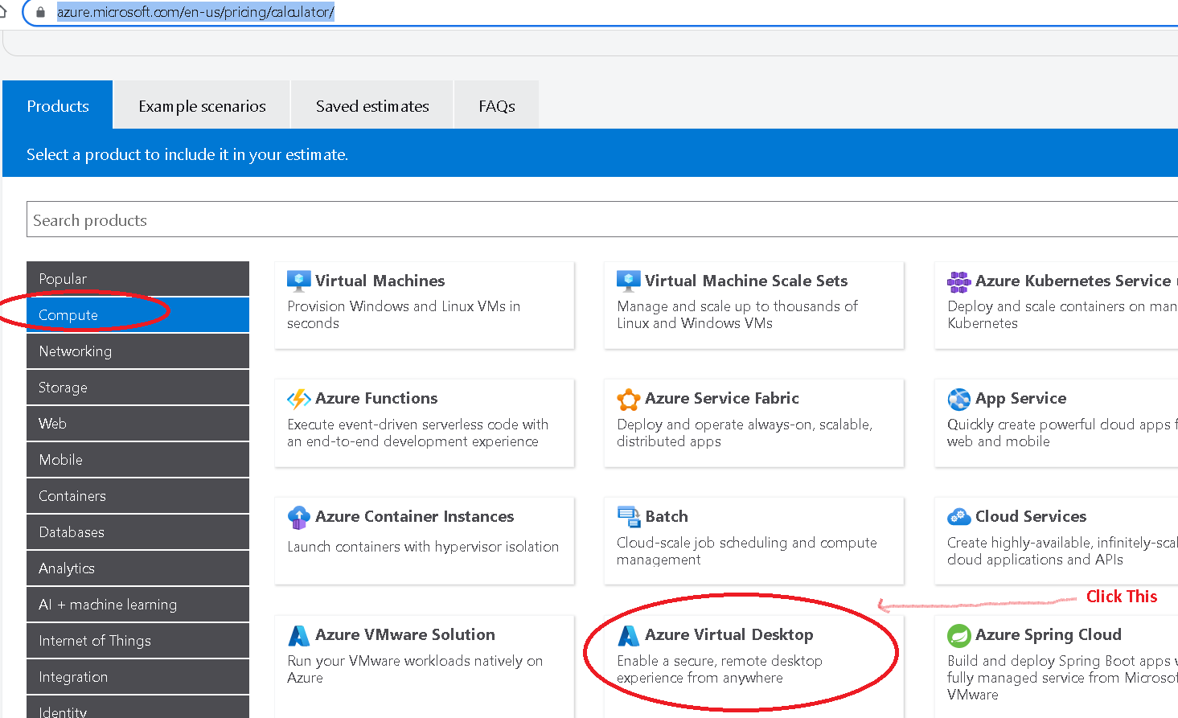

=====================================================================

**AWS Workspace Architecture**

https://docs.aws.amazon.com/whitepapers/latest/access-workspaces-with-access-cards/architecture-overview.html

**AWS Workspace Cost Calculator**

<https://calculator.aws/#/addService?refid=20251d67-880f-4aa4-8138-3384ccb477aa>

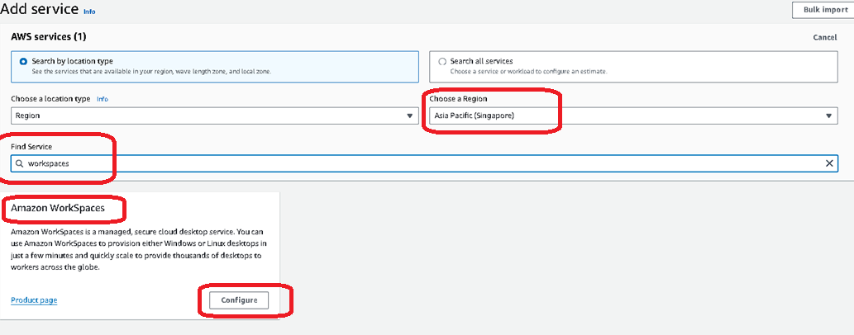

======================================================================

**Citrix XenDesktop Architecture**

<https://docs.citrix.com/en-us/xenapp-and-xendesktop/7-15-ltsr/technical-overview.html>

**Citrix Virtualization on Google Cloud**  
https://community.citrix.com/tech-zone/design/reference-architectures/citrix-google-virtualization/

**Citrix Google Cloud Cost Calculator**

<https://www.citrix.com/platform/citrix-app-and-desktop-virtualization/resources/google-cloud-daas-calculator.html#/>

**======================================================================**

**VMware Horizon Architecture**

<https://docs.vmware.com/en/VMware-Horizon/2106/horizon-architecture-planning/GUID-C6AD7E43-FC69-4D8C-AB97-423FC0DCDB3D.html>